

N-care

“Connecting Health and knowledge.”

Project Proposal

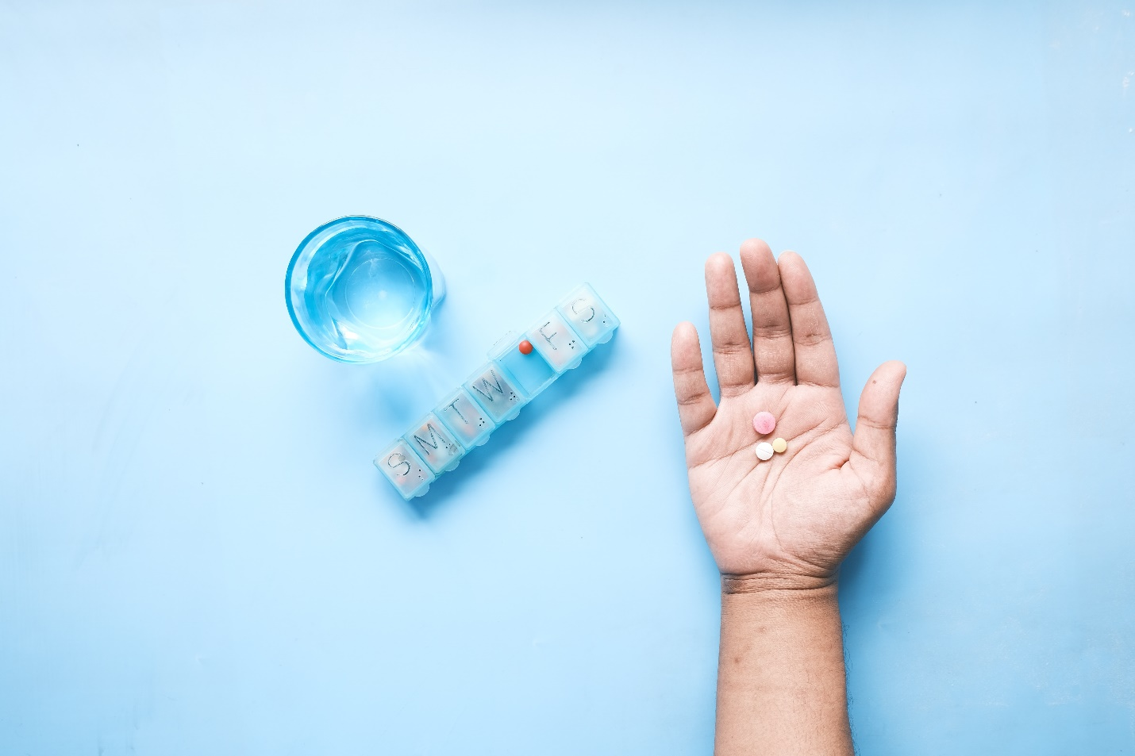

Module: Mobile Application Development

Team : CodeCrafters

**Table of content**

1)Introduction

1.1. Problem Identification

1.2. Proposed solution

2)Scope of the system

2.1. Requirements

2.2. Features

3)Diagrams

3.1.ER Diagram

3.2. Use-Case Diagram

3.3. Class Diagram

4)Main Pages of the application

5)” N-Care” Logo & color pallete

6)Prototype

7)Conclusion

8)Team member details

9)GitHub repository link

**1)Introduction**

The Medical Center of NSBM consists of a medical unit, dental unit, and counseling. Medical unit and counseling are provided services free of charge to all students of NSBM. But some services are charged at the dental unit.

Currently, these all processes in the Medical Center of NSBM are going on manually and we could find many problems with this current system. “N- Care” will be developed to address those problems.

1.1. problem identification

* **Manual Processes:**

The existing medical center uses manual procedures to conduct a variety of operations, including communicating, managing medical records, arranging appointments, and making payments. Students may need to go to the medical center to make an appointment and payments are done by manually, which will cause significant wait periods and inconvenience. Handling medical records manually raises the possibility of mistakes, misplaced important documents, and problems with patient data retrieval. Additionally, manual communication techniques like in-person announcements or paper-based alerts take time and might cause crucial information to be shared later than planned.

Also, minimizing the use of paper, cardboard, etc. due to the online system, may be a good practice for the green concept of NSBM.

* **Limited Accessibility:**

There are a number of issues that affect how easily students may receive medical care. There may be a shortage of medical personnel, which might result in higher wait times or trouble getting appointments. Students who have mobility issues or busy academic schedules may need to physically attend the medical center, which can be difficult and time-consuming. Lack of access to medical care can lead to improper treatment, delayed diagnosis, and decreased student health.

* **Limited Communication:**

There is not any effective communication system between the medical center and students currently.

Important announcements, such as health campaigns, preventative measures, or modifications to medical services, cannot be informed to students. Students may find it difficult to get timely information on their health-related problems, ask questions, or seek medical assistance if there are no real-time communication channels available. So, it is needed to have an effective way of getting the messages to all students on time.

The proposed solution seeks to address these issues by creating a mobile application for the university medical center that will streamline procedures, improve accessibility, enhance communication, ultimately giving students a more effective and user-friendly healthcare experience.

1.2. Proposed solution

* **Improved Access and Convenience:**

The use of the mobile app will transform how students get medical care. Students may simply arrange appointments using the app at their chosen times, cutting down on wait times and the need for in-person meetings or drawn-out phone conversations. Students will be able to explore available appointment times, and promptly get confirmation from an effective User Interface design. This enhanced accessibility and convenience guarantees that students can effectively manage their health requirements and receive timely healthcare help, improving their general wellbeing.

* **Enhanced Communication:**

A stronger platform for contact between the medical center and students will be provided via the mobile app. Real-time notifications will allow the medical center to communicate significant information with the students directly, such as health campaigns, immunization drives, or changes to medical services. Students will be able to communicate with healthcare experts in two directions by using in-app messaging and chat tools to ask inquiries, get answers to their medical queries, and request information. This improved line of communication guarantees prompt and efficient help for students' health issues, encouraging a cooperative and flexible healthcare environment.

* **Streamlined Processes:**

Various manual processes will be automated by this mobile application. Automated appointment scheduling will eliminate the need for manual booking and lessen schedule difficulties. Students can make payments with online payment methods which makes it easier and saves time and it increase the accuracy in billing. Healthcare workers will be able to readily access and update patient information due to the digitization of medical record management. This automation provides accurate and current medical records while minimizing mistakes and easing administrative strain. Time is saved, mistakes are reduced, and overall productivity at the medical center is increased thanks to these simplified procedures.

* **Sustainability and Green Concept:**

By switching from manual to digital platforms, the mobile app supports environmental sustainability and is in line with the university's green idea. This online platform will reduce the need for superfluous paperwork, reduce paper usage and the environmental impact of printing and keeping actual papers. So, the medical center can increase efficiency, and help create a greener campus by optimizing resource management with the app. The app's digital format promotes the university's dedication to sustainability and serves as a model for other divisions within the organization.

In conclusion, the suggested mobile app solution(N-Care) for the university medical center would greatly increase student access and convenience, improve communication between the medical center and students, streamline procedures, and support sustainability via digitization. These advantages will result in a more effective and convenient healthcare experience, guaranteeing that students get prompt, high-quality medical treatment while supporting the university's green approach.

**2)Scope of the system**

2.1. Requirements of the system

**Functional Requirements**

* **User Registration and Authentication:**

For our mobile application, which is targeted the medical Center of our university, User Registration and Authentication are crucial functional needs. We provide users with the choice of easily creating accounts within the app through a particular registration process or by using their university login and password information. We give the installation of safe authentication procedures priority to guarantee the security and privacy of user data. If the submitted credentials are accurate, our system securely stores usernames and passwords, enabling users to log in without any problems. These precautions ensure the accuracy and security of user data, promoting a secure environment within the mobile application for the medical Center.

* **Webservice integration:**

We ae going to include web service integration as a crucial functional requirement. Users will be able to easily install the app through the Play Store to increase accessibility, guaranteeing a large user base globally. Our mobile application's smooth integration of web services is one of its key features. We can create connectivity between the app and pertinent online platforms or databases by integrating web services. Users now have access to real-time data such as updates on medical centers, appointment scheduling, and test results. Additionally, it enables effective data sharing, enabling customers to send questions or make service requests directly through the app. We expand the functionality and audience of our mobile application by including web service integration, giving consumers a thorough and engaging experience when using the medical Center services at our university.

* **Notifications and Reminders:**

A dependable notification system will be included in the mobile application for the university's medical Center to ensure that students receive timely reminders and alerts. To make sure that students are aware of their healthcare responsibilities, these reminders will contain upcoming appointments, prescription plans, and follow-up appointments. Users will have the freedom to select their preferred method of getting notifications, such as push notifications, through customizable notification options, to meet individual preferences. By including this function, our mobile application hopes to improve interaction and participation while keeping students connected and informed about their duties and activities at the medical Center.

* **Database integration:**

Database integration is a crucial functional necessity for the proposed mobile application. Users may easily access their history, data, and passwords by the databases that securely preserve user records, including previous credentials. We enable effective data management and give users a complete view of their information through the mobile application by integrating databases. This integration not only ensures proper record-keeping within the medical Center but also streamlines data retrieval, encouraging transparency and giving users authority over their own data.

* **Real time updates:**

Our project proposal includes real-time updates as a critical functional requirement. We have included features that provide real-time updates to ensure an effective appointment booking system. The program will immediately indicate if a user's chosen time slot to meet with a doctor has already been reserved by another person. Users may easily find available time slots and decide on their appointments by this real-time update tool. We can efficiently manage the appointment schedule and ensure appropriate use of doctors' time by giving this information in real-time. By eliminating the need for manual coordination and providing a smooth and current booking procedure within the medical Center mobile application, this feature improves user experience.

* **Integration with External Systems:**

In our project proposal for the mobile application of the medical Center at our University, integration with external systems is a crucial functional necessity. By smoothly connecting the app with multiple university medical Center information systems, labs, and payment gateways, we hope to increase its usefulness. Users now have access to a variety of services and data, such as medical records, test results from labs, and online payment choices, thanks to this connection. We place a high priority on safe data sharing and abide by industry standards to guarantee the confidentiality of sensitive information while it is being transmitted. We also recognize the significance of dependability and compatibility in these connections. We will carry out thorough testing to confirm the compatibility, functionality, and dependability of the integrations to guarantee trouble-free operation. Our mobile application for the medical Center will give users a thorough and streamlined experience by prioritizing integration with external systems, boosting access to crucial services and information while upholding the highest standards of security and dependability.

**Non-Functional Requirements**

* **User Interface Design:**

Our mobile application's user experience will take advantage of Material Design principles to captivate and engage users. We intend to build an interface that is simple to learn and use, with an emphasis on doctors, dentists, and counsellors. We will use different fonts, font colors, and font sizes that call attention to crucial elements to emphasize essential information. We will rely on their cognitive ability and send just one reminder since university students typically have better memories and technical understanding. To improve the overall user experience, visual representation will be introduced through the usage of pertinent photographs. Our mobile application will feature a fantastic UI/UX that is simple to use and adheres to best practices. Clear navigation, ease of use, and aesthetically pleasing components will be prioritized throughout the design process. In addition, we are dedicated to upholding set criteria to guarantee accessibility. All users of the medical Center mobile application will have a seamless and eye-catching experience thanks to the combination of these elements in our user interface design.

* **Performance:**

Our main goal is to provide a seamless and easy-to-use user experience through improving performance in numerous areas. The program will first be improved to guarantee speedy loading times and effective data retrieval. Users will be able to quickly access the needed data as a result, reducing any potential delays or annoyance. We will carry out extensive performance testing to guarantee uninterrupted service during periods of peak demand. By simulating high usage scenarios, these tests will help us locate and resolve any potential bottlenecks or response problems. In addition, we place a high priority on device compatibility, working to ensure that the mobile application may be installed on any device, regardless of its operating system or technical requirements. We ensure that data is integrated and synchronized throughout the system by establishing a connection between databases, preventing any isolation or fragmentation. Finally, we will manage the backend infrastructure to make sure that data transfers and communications between the mobile application and the backend run without a hitch. By streamlining communication and enabling seamless data interchange, this backend management will improve the performance of the mobile application. Our mobile application for the medical Center will provide a top-notch user experience with the best speed, responsiveness, and dependability by putting these performance-oriented measures into place.

* **Platform Compatibility:**

Our mobile application for the medical Center at our university must be platform compatible. By concentrating on Android compatibility, we hope to guarantee broad accessibility for our users. We make sure that a broad variety of devices can use our services without any problems by building the application to support Android. With this strategy, we can serve the varied user base inside the university community. We also recognize the need to provide constant user experience across various devices. As a result, we will give priority to compatibility across a range of operating system versions, screen sizes, and resolutions.

This guarantees that customers will get a consistent and user-friendly interface regardless of the used device, whether it be a smartphone or tablet. By placing a strong emphasis on platform compatibility, we expand the audience for our mobile application while ensuring a smooth and delightful user experience on all Android devices.

* **Localization and Language Support:**

We want to provide a user-friendly environment that serves our varied user base, which includes both domestic and foreign students. We will give English language functionality in the application priority since English is a language that university students are familiar with. This guarantees that users can quickly browse and understand the application's capabilities and information. We do recognize the significance of providing a localized user experience, though. To do this, we shall consider the unique linguistic and cultural quirks of our user base. We can modify the application to confirm regional conventions, tastes, and linguistic variances by taking these peculiarities into account. Localized date formats, monetary symbols, and any other pertinent cultural concerns can all be incorporated in this way. We improve usability and encourage a stronger sense of familiarity and engagement for our users by providing a localized user experience. We want to offer each user who uses the medical Center services at our university a seamless, personalized experience that meets their needs.

* **Security and Privacy:**

“N-care” mobile application of the medical Center at our university places a high premium on ensuring the security of user information and maintaining confidentiality. We have put in place several significant security measures to achieve this. User authentication is one of these controls; to access the program, users must input the proper credentials. Only authorized users are permitted access, and unauthorized use is prevented by this robust barrier of authentication.

We have added strong security measures, such as encryption and safe storage, in addition to user authentication. We can protect sensitive user data during transit and storage by using encryption, rendering it unreadable to unauthorized parties. Secure storage procedures further strengthen user data security by lowering the possibility of breaches or leaks.

Using these methods, the codebase is protected against potential security threats, lowering the possibility of breaches, and preserving the integrity of the program.

We put a high priority on the security and privacy of our users by using user authentication, encryption, and secure coding approaches. Our mobile application is intended to offer a secure and reliable environment, protecting private user information, and guaranteeing that user data is kept private.

2.2. Features of the system

This is an overview of the features included in the mobile application being developed for the NSBM Green University Medical Center. The application serves as a one-stop solution for students, offering access to three main units: the Medical Unit, Dental Unit and Counseling Unit. By providing a comprehensive set of features, our application aims to enhance the efficiency and accessibility of healthcare services within the university. By incorporating various features such as login and sign-up pages, appointment scheduling, patient past records, prescription records, feedback forms, notification reminders, secure payment gateways, and services like doctor information service, news, and student profile. The application offers a holistic and user-centric solution for students seeking healthcare within the university.

**Medical Unit Features**

* **Login and Sign-up:**

To ensure the security and privacy of user data, the application will incorporate login and sign-up pages. Students will be required to create an account or log in using their credentials granting them access to the Medical Unit's services and features.

* **Appointment Booking:**

A core feature of the application will be the ability for students to easily book appointments with doctor from the Medical Unit. The appointment booking system will offer an easy-to-use interface that will let students choose their preferred time slots from the available options. This feature streamlines the appointment process, reducing waiting times and enhancing overall efficiency.

The application will include a calendar feature to make scheduling appointments easier. Students will be able to select an appropriate date and time for their appointment. By visualizing the schedule, students can easily find and select an available slot that fits their schedule.

* **Patient Student Past Record:**

The application will give students access to their medical history in order to maintain continuity of treatment and give comprehensive medical services. Students can consult their medical records during consultations by using the patient history record feature, which displays earlier diagnosis reports. Doctors will be able to give individualized care by using this useful resource to learn more about the students' medical histories.

* **Prescription Record:**

Students will be able to check their previous prescriptions for medications due to the prescription record function. Students who have access to their prescription history can quickly consult past prescriptions that were prescribed by doctors. This feature promotes patient safety and empowers students to actively participate in their healthcare decision-making process.

* **Feedback Form:**

The application will come with a feedback form in order to keep improving the standard of services provided by the Medical Unit. Students can submit any issues or comments they may have as well as feedback on their experiences and areas that could be improved. The overall quality of service will be improved by using this feedback method to help identify and address areas that need improvement.

* **Notification Feature:**

The application will feature a notification system designed to send timely reminders to students before their scheduled appointments. Students can keep informed and avoid missing their doctor appointments by checking up for notifications. The purpose of this function is to increase appointment adherence and optimize the use of healthcare resources.

**Dental Unit Features**

* **Login and Sign-up:**

Similar to the other units, the Dental Unit features a secure login and sign-up page. Students will have the option to create a new account or log in using their existing credentials. This ensures privacy and data security, allowing students to access their dental-related information securely.

* **Appointment Booking:**

The application includes a user-friendly appointment booking feature specifically designed for the Dental Unit. Based on their preferred date and time, students can conveniently schedule their dentist visits. This feature guarantees effective management of dental resources and minimizes student wait times.

* **Patient Past Records:**

The application grants students’ access to their dental records, including past treatments and procedures. By having access to their patient’s past records, students can review their dental history and share relevant information with the dental professionals. This function encourages continuity of care and aids dentists in making informed treatment choices.

* **Prescription Record:**

The prescription record feature enables students to view their past dental prescriptions, including medications and post-treatment instructions. This knowledge ensures accurate communication between dental professionals and provides a convenient reference for students.

* **Feedback Form:**

To continuously improve the quality of dental services, the application incorporates a feedback form. The dental experiences of the students can be reviewed, and they can express their feelings or concerns, as well as proposed areas that could be improved. This feedback system enables the Dental Unit to quickly identify and resolve any problems, ensuring satisfaction for students and improving the quality of the general dental treatment offered.

* **Notification Feature:**

The application's notification feature sends reminders and notifications to students for their upcoming dental appointments. These alerts assist students in staying informed and guarantee that they do not skip their planned appointments. Students can efficiently manage their dentist appointments by getting timely reminders.

* **Payment Gateway:**

To simplify the payment process for dental services, the application integrates a secure payment gateway. Students can make payments for dental procedures, such as teeth cleaning or filling, directly through the application. The payment gateway ensures a safe and convenient transaction experience, eliminating the need for manual cash transactions and enhancing overall convenience.

**Counseling Unit Features**

* **Login and Sign-up:**

The application will include dedicated login and sign-up pages for students accessing counseling services. By ensuring secure access, students can confidently engage with the Counseling Unit's resources.

* **Appointment Booking:**

To schedule counseling sessions, students can utilize the appointment booking feature specifically tailored for the Counseling Unit. This feature allows students to select their preferred time slots and facilitates the allocation of counseling resources effectively.

* **Patient Past Record:**

The most important aspect of mental health support is continuity of care. Therefore, the application will enable students to access their past counseling records. This feature ensures that counselors have access to the necessary information, fostering personalized counseling sessions.

* **Prescription Record:**

The prescription record feature will give students access to previous counseling recommendations or resources that their counselors have shared with them in the context of counseling services. The effectiveness of counseling sessions is increased due to this feature, which encourages cooperation between students and counselors.

* **Feedback Form:**

To continually enhance the quality of counseling services, a feedback form will be integrated into the application. Students can provide valuable insights, suggestions, and feedback on their counseling experiences. This feedback mechanism empowers students and contributes to the ongoing improvement of counseling services.

* **Notification Feature:**

Similar to the Medical Unit, the Counseling Unit's notification feature will send reminders to students before their counseling appointments. This proactive approach helps students stay engaged and committed to their mental health support.

With this application we are going to provide additional services such as Doctor Information, News and Patient student Profile.

**Doctor Information Service:**

The application features a dedicated Doctor Information service that provides detailed information about doctors within the Medical Unit. Students can access information such as doctors' names, professional introductions, degrees, areas of expertise, and their professional experience. This feature helps students make informed decisions when selecting doctors for their consultations.

**News Service:**

The News service provides students with the latest information on common diseases, preventive measures, health tips, and other relevant news. This feature keeps students informed about health-related topics and empowers them to take proactive steps in maintaining their well-being.

**Student Profile:**

The Student Profile feature allows students to view and manage their personal information. It displays details such as the student's name, batch, degree program, address, telephone number, and medical history. Additionally, it provides a record of their payments made for healthcare services. This feature ensures easy access to important student information and promotes effective communication between students and healthcare providers.

**3) Diagrams**

3.1.ER Diagram

3.2. Use-Case Diagram

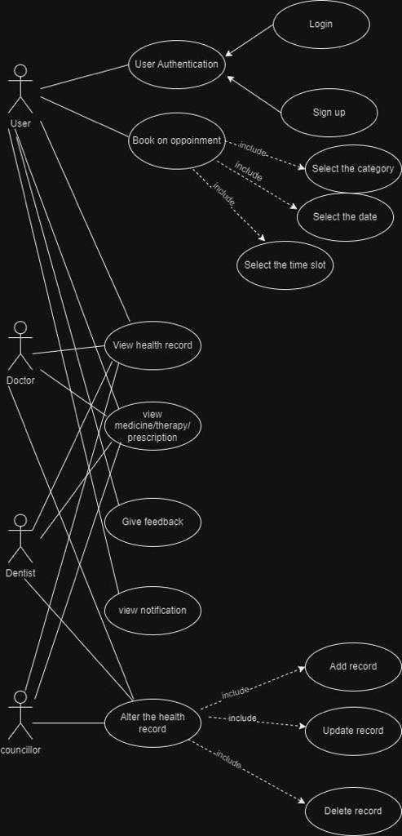

3.3. Class Diagram

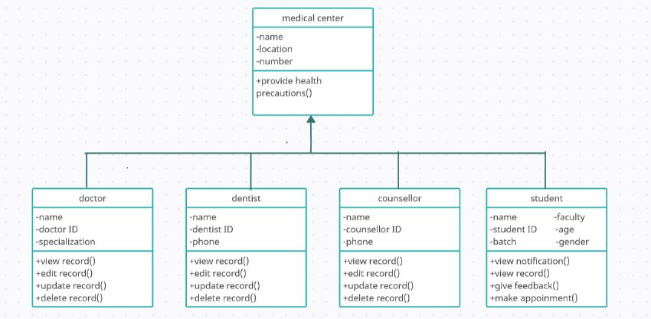

**4)Main Pages of the application**

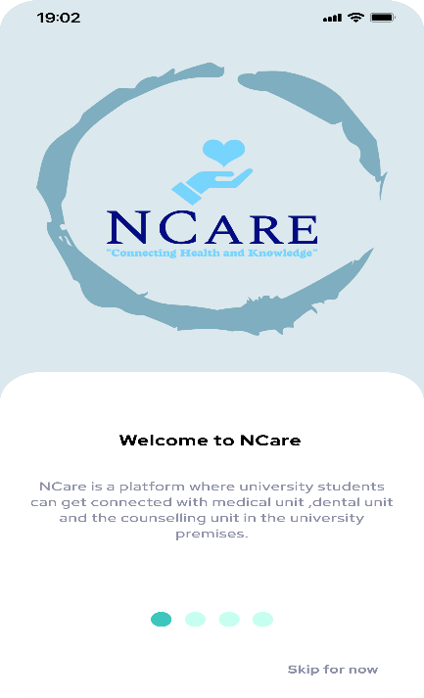

The second splash screen gives a brief description about the medical unit and how users can connect with the doctors in the medical unit while the third splash screen gives a brief description about the counselling unit and how users can connect with the counsellor and get the mental health advice.

This is the very first page the user will see upon entering the app. The first splash screen greets the user welcome as soon as they log in. It shows what are the units which students can connect via this N Care mobile application.

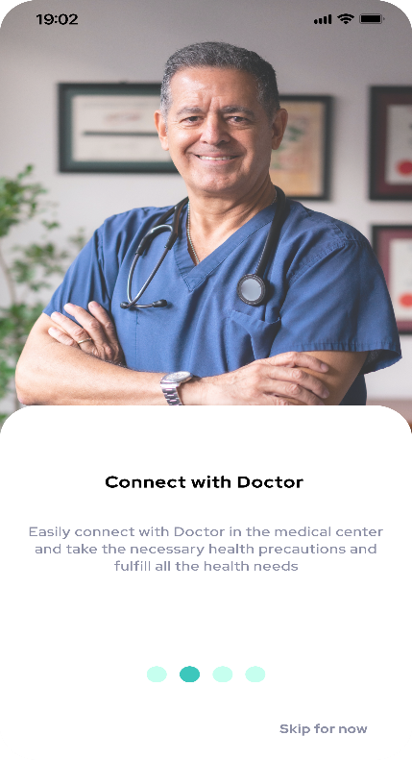

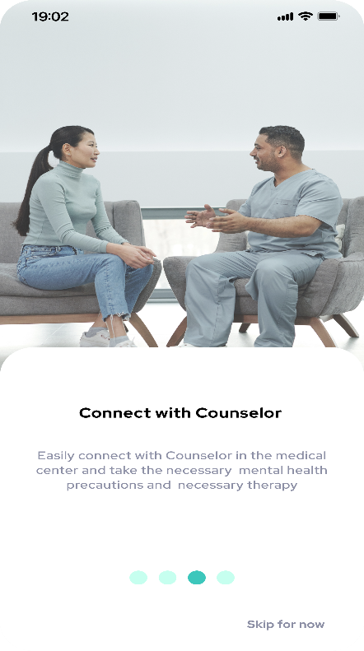

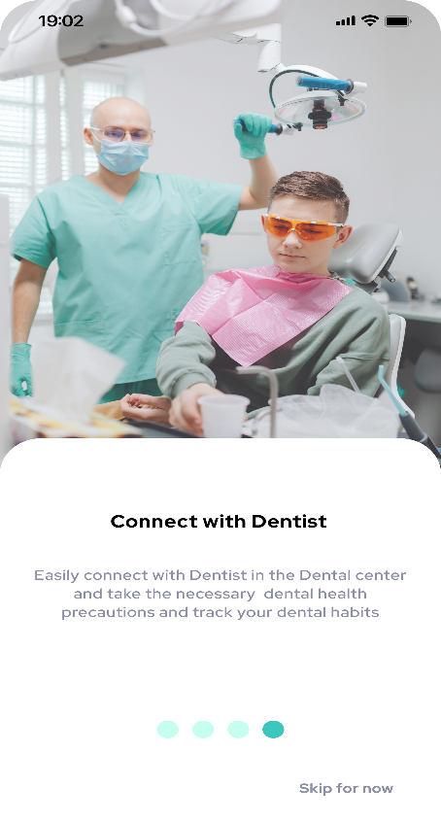

The last splash screen which gives a brief description about the dental unit and how users can connect with the dentist and get the necessary dental care.

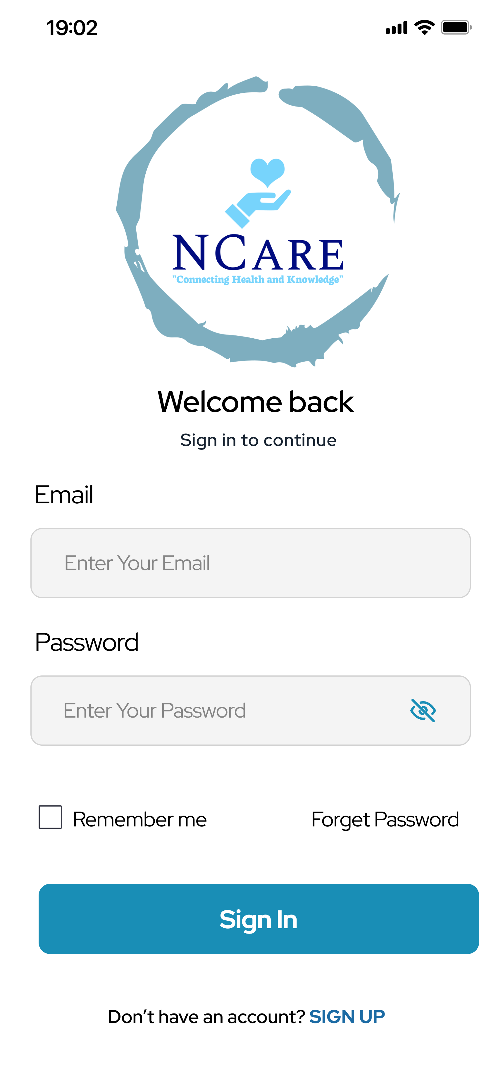

This is the login and sign-up page. In here if a user is existing user, they can sign into the application by providing email and password. If it is a new user, they can sign up by providing name, email, password, and mobile number.

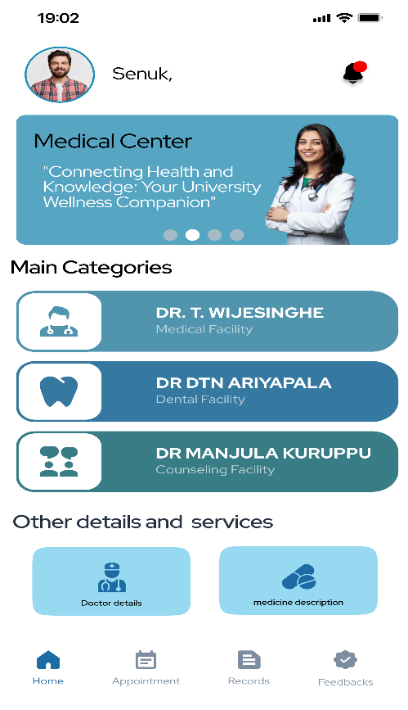

This is the home page of the N-Care mobile application. In here users can choose the facility they want from main categories. It has three facilities which are medical facility, dental facility, and counselling facilities. Other than that, they can direct to the doctor details and medicine description pages from the home page.

This page is about doctors’ details. In here you can see who the doctors in the medical unit are and by clicking more detail button user can see detailed description about the doctor.

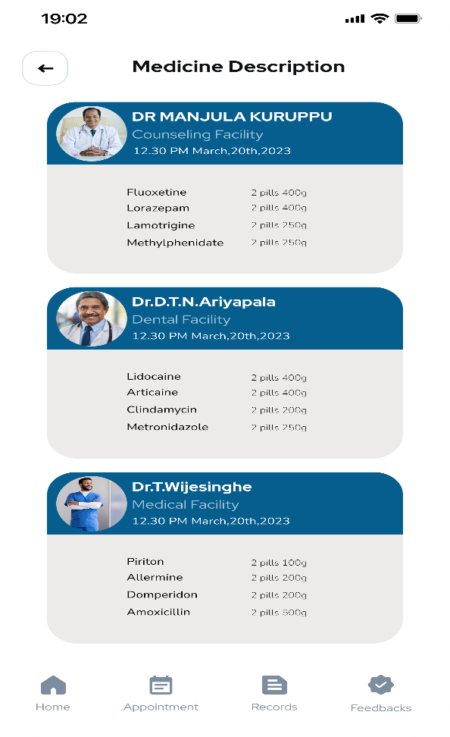

In this page student can see their past medical description. they can see what the facility is they got and what are the medicines they got in previous sessions.

In this page student can make their appointment. Before making an appointment, they have to select their preferred date from the calendar and select the session they want. In sessions they have two options which are morning and evening sessions. After selecting their sessions, they can select the time slots which are available.

After the student makes an appointment, they will direct to this form which get patient details. In here they have to fill their basic information and submit it.

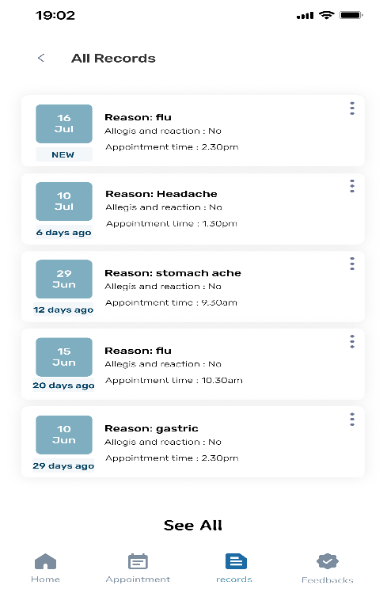

In this page student can see their past records. It shows users the date of their past appointment, what is the reason and more.

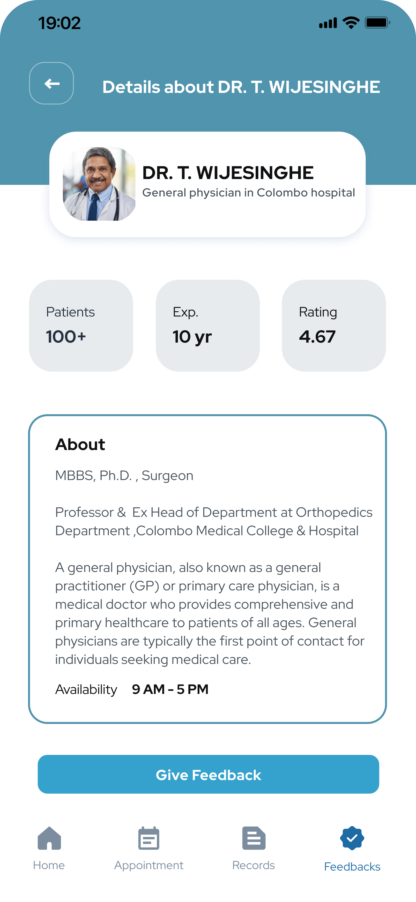

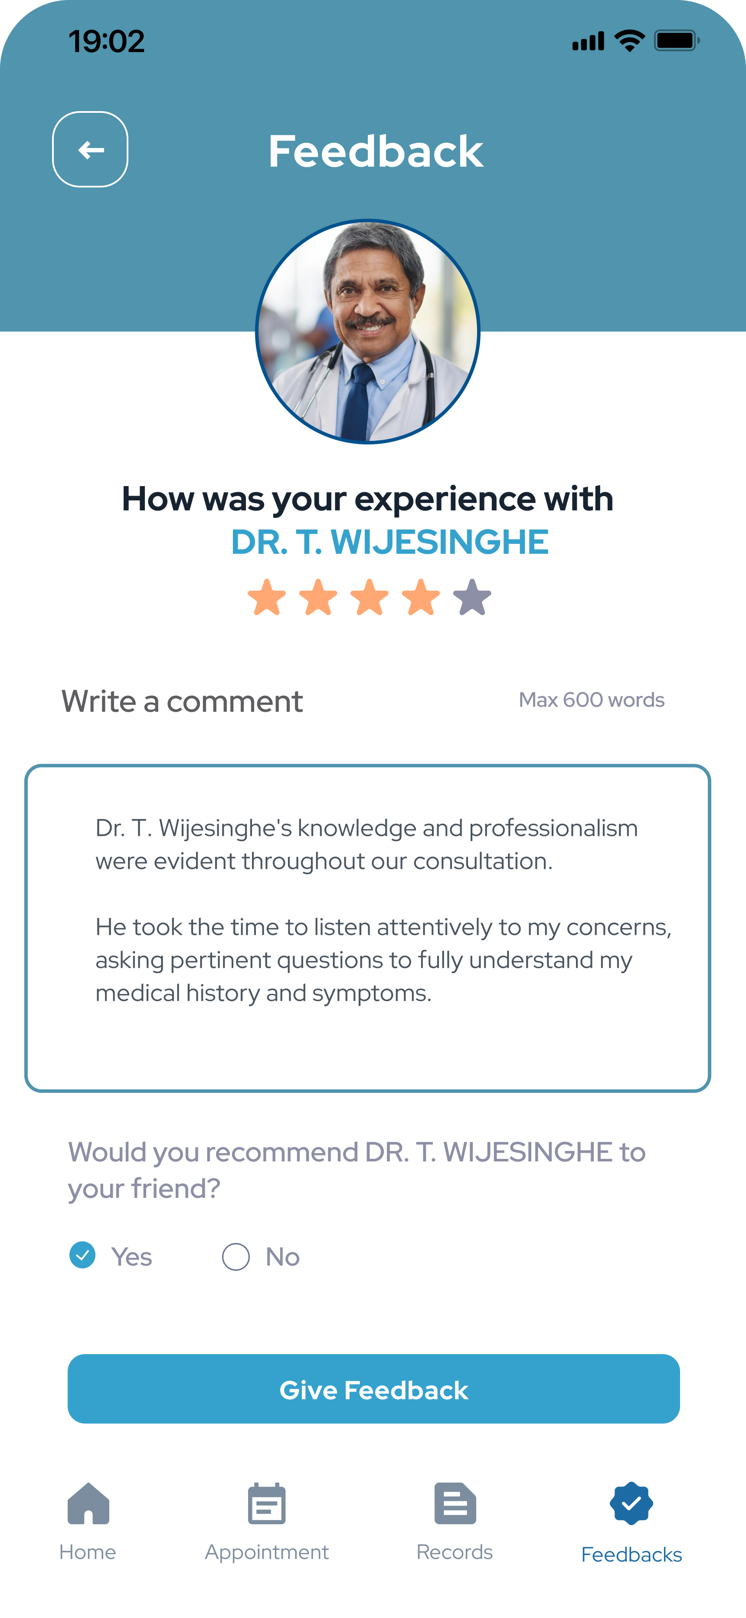

This is the feedback page which student can rate and give feedback to the doctors. In here user can write a feedback can select that whether they recommend this doctor to their friends or not.

This is the profile page. In here student can view their history, personal detail, location, payment methods and more details.

When user click on the notification icon on the home page, they will direct to this notification page. In here user can see their schedules, medicines, record, feedback, and doctor updates.

**5)” N-Care” Logo & Color Pallete**

**Logo**



**Color pallete**

**7)Conclusion**

In conclusion, by offering a comprehensive online platform, the proposed initiative "N-Care" seeks to revolutionize the way NSBM students obtain healthcare services. We will develop a user-friendly, cross-platform mobile application that offers smooth access to care by utilizing the Flutter framework and Dart programming language. For the back end, integrating C# and PHP will allow for effective data management and secure communication.

Version control, design purposes, collaborative development, and code quality will all be made possible through the usage of industry-standard technologies like Visual Studio Code, GitHub and Figma. We are sure we can provide a dependable and high -quality solution with the help of these technologies and tools.

University students will be empowered by "N-Care" since it will promote their wellbeing and provide them with caring assistance. The suggested system will increase accessibility, simplify procedures, and promote communication between students and medical professionals. We will create a strong, scalable, and user-friendly mobile application by using the features of Flutter, Dart, C#, PHP, Visual Studio Code, and GitHub.

“N-Care" will not only help university students who are looking for healthcare with their current problems and pain spots, but it will also improve their general wellbeing and academic performance. With this proposal, we want to get the backing and go on with "N-Care" development so that we can benefit the student community.

**8)Team member details**

|  |  |
| --- | --- |
| **Name** | **Student Id** |
| S.T. Kumasaru (Leader) | 23686 |
| N.A.K.A. Manupriya | 22741 |
| D.M.M. Gunasekara | 23595 |
| K.S.H. Karunarathna | 23847 |
| R.M.A. Pramodya | 23910 |
| L.D.L. De Silva | 21503 |

**9)GitHub repository link**

[**https://github.com/Senuk27/MAD-project.git**](https://github.com/Senuk27/MAD-project.git)

**Figma Link**

[**https://www.figma.com/file/tACDhqUYsNGPzeQjfVl6ld/RELICON?type=design&node-id=0%3A1&mode=design&t=DGKEtZnqx3hGgu0g-1**](https://www.figma.com/file/tACDhqUYsNGPzeQjfVl6ld/RELICON?type=design&node-id=0%3A1&mode=design&t=DGKEtZnqx3hGgu0g-1)